Investigation 8 Function CompositionName:_______________________

Composition of functions can be written two ways and *g*(*f*(*x*)). Both are read “*g* of *f* of *x*.”



Just like Order of Operations, you should do the inside function first.

Let *f*(*x*) = *x*3 and *g*(*x*) = *x*2 + 3

*g*

*f*







Do this second

Find = *f*(*g*(2))

Do this first.



Since *g*(*x*) = *x*2 + 3, first find *g*(2).

*g*(2) = 2 + 3 =

What value for *g*(2)? _________

Now go onto the *f*(*x*) = *x*3, what will you use for *x* this time? _____________

So *f*(7) = 3 =

Check: 343

Using the same functions as above, find *f*(*g*(-4)). Use the diagram below to help you.

1st input

-4

1st 2nd

Output Input

19 19

2nd Output

____________________

(-4)2 + 3

*g*(*x*) = *x*2 + 3

(19)3

*f*(*x*) = *x*3

Check: 6859

Try one more…….

*f*(*x*) = *x* – 2 *g*(*x*) = 3*x* + 10

1. Find  = *g*(*f*(6)). Do you remember where to start? ____________(Think about Order of Operations.)

*g*(*f*(6)) = *g*( ) = *g*(4) = = 22

1. Find 

= *f*( ) = *f*(3*x* + 10) = =

Check: 3*x* + 8

1. Let *f*(*x*) = *x*2 and *g*(*x*) = 3*x* + 1. Find and simplify (*f* ∘ *g*)(2*t*).

We can also find a composition from a map using the same concept.

To find a function value from a chart, like *g*(3), go to the map of *g* at *x* = 3. This is the left side since the arrows point to the right. Follow the arrow to the right side. So, *g*(3) = 2.

0

2

3

6

-4

0

2

8

0

1

2

3

1

3

5

7

*g*

*f*

1. Find *g*(2) =__________
2. Find =__________
3. Find =__________
4. Explain why  does not exist.

We can also find a composition from a graph using the same concept.

To find a function value from a graph, like *f*(-2), go to the graph of *f* at *x* = -2 and find the *y*-value on the graph. So, *f*(-2) = -1.

*g*

*f*

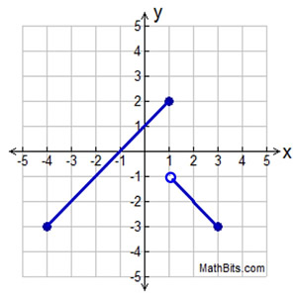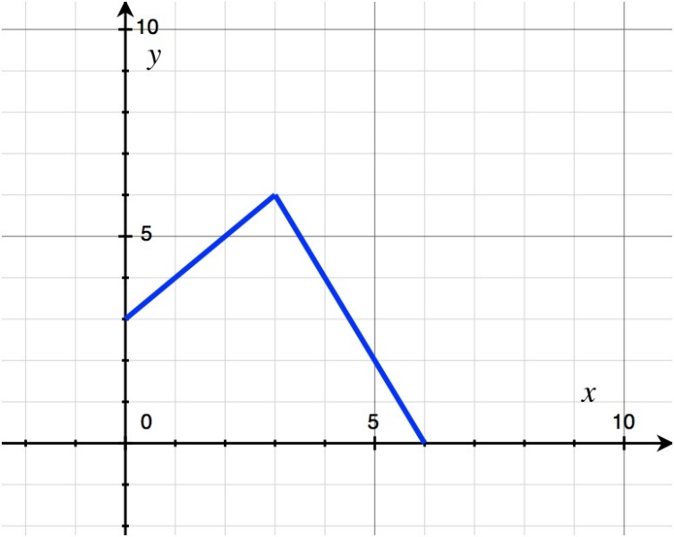

1. Find *g*(5) =__________
2. Find (*f* ∘ *g*)(5) =__________
3. Find (*g* ∘ *f*)(1) =__________
4. Explain why (*f* ∘ *g*)(-3) does not exist.